DSA0502 QUERY PROCESSING FOR DATASCIENCE
CO1 AT2 Application-Based Questions

1. Aim
To read product information from an XML file, extract and display products belonging to the Electronics category, calculate the average product price, and save the filtered Electronics products into a new XML file using Python.
Description
E-commerce applications store product information such as product ID, name, category, and price in structured formats like XML. In this assignment, the XML file is parsed using Python's xml.etree.ElementTree module to retrieve product details. Th
e data is then filtered to display only products in the Electronics category, the average price of all products is calculated, and the filtered products are exported to a new XML file for further use.
Tools Used
- Python 3
- xml.etree.ElementTree module
- XML File (products.xml)
- Visual Studio Code / IDLE / PyCharm
Result
The product information was successfully read from the XML file, the Electronics category products were filtered and displayed, the average product price was calculated accurately, and the filtered products were successfully saved into a new XML file (electronics_products.xml).

PROGRAM:
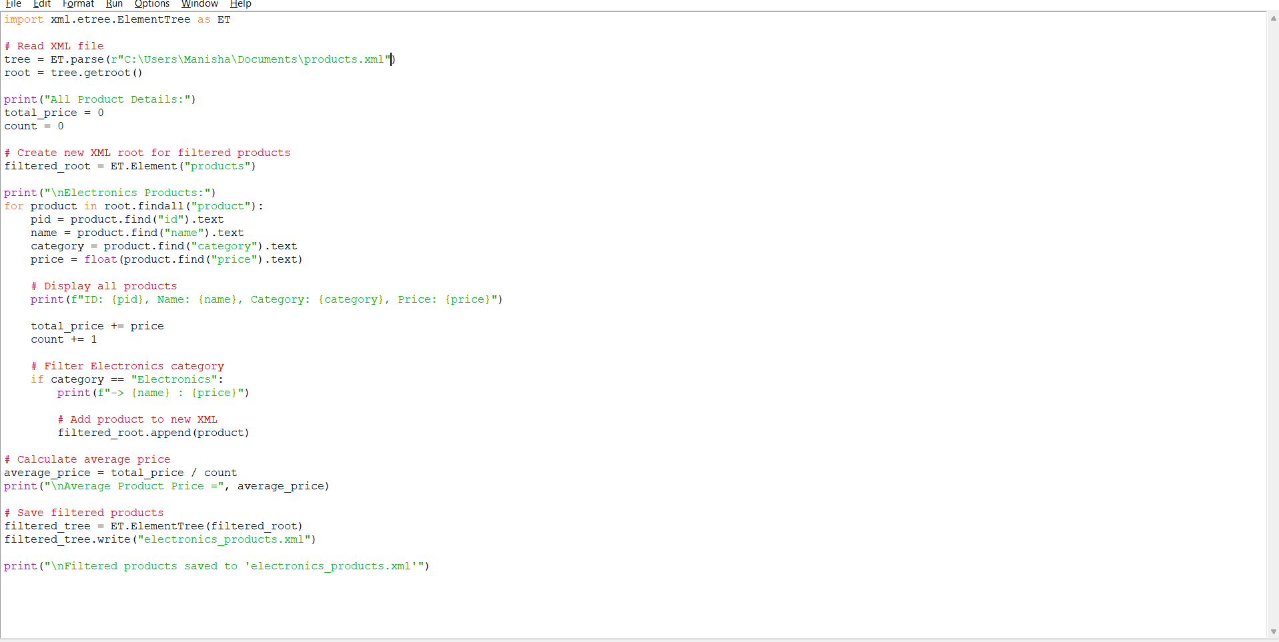

OUTPUT:
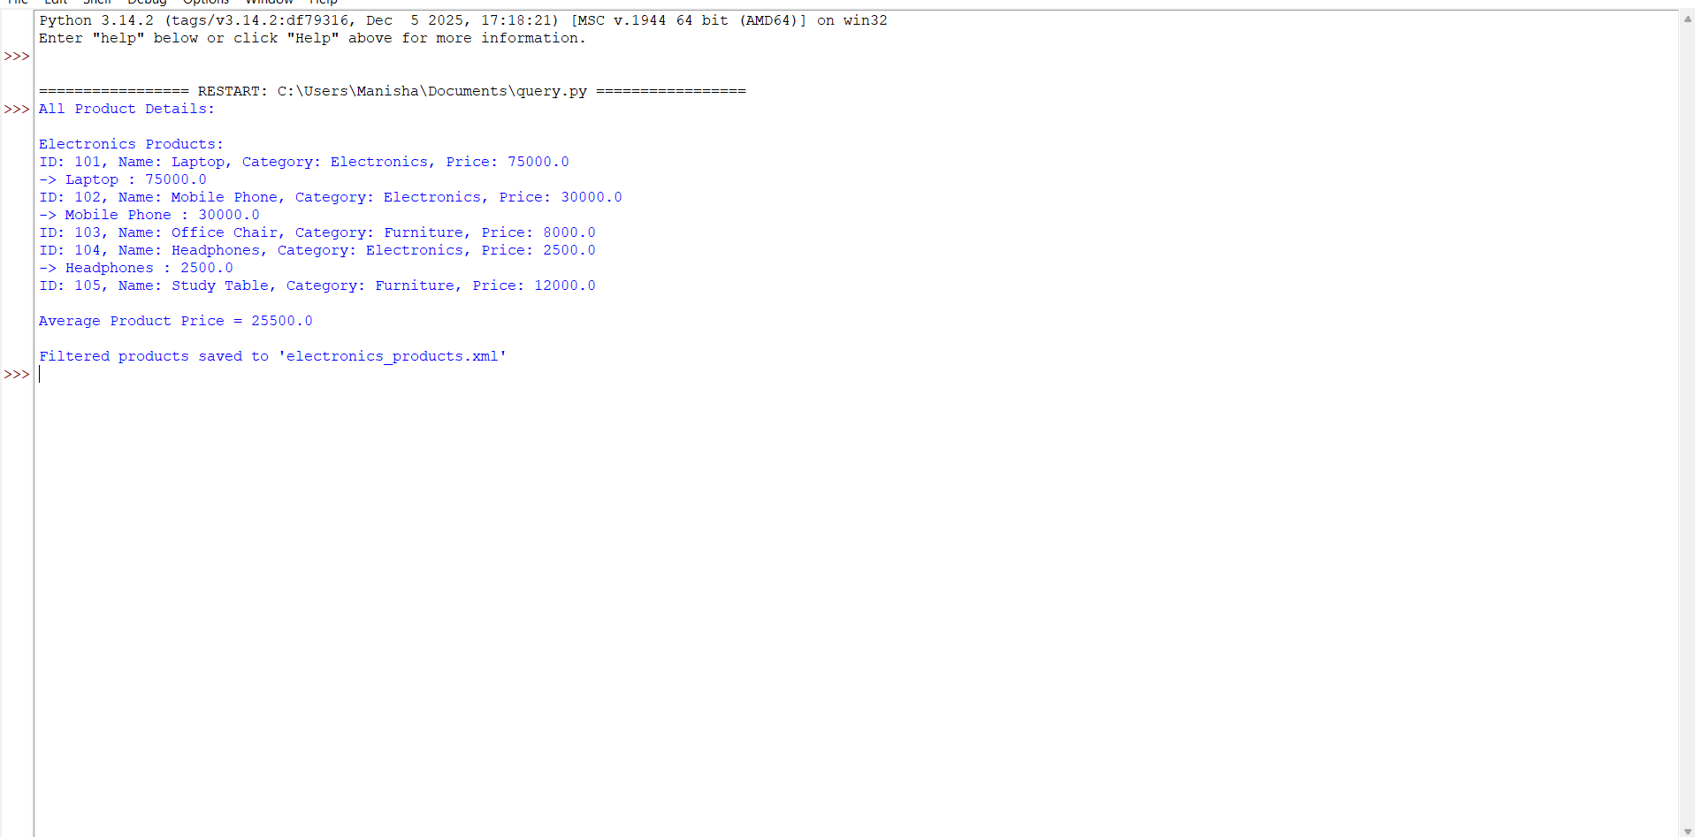

AIM:
The aim of this program is to read the University Admission data from a CSV file using the Pandas library, identify duplicate student records, remove duplicate entries to maintain data integrity, display the details of students admitted to the CSE (Computer Science and Engineering) department, and save the cleaned dataset into a new CSV file for future use.

PROGRAM:
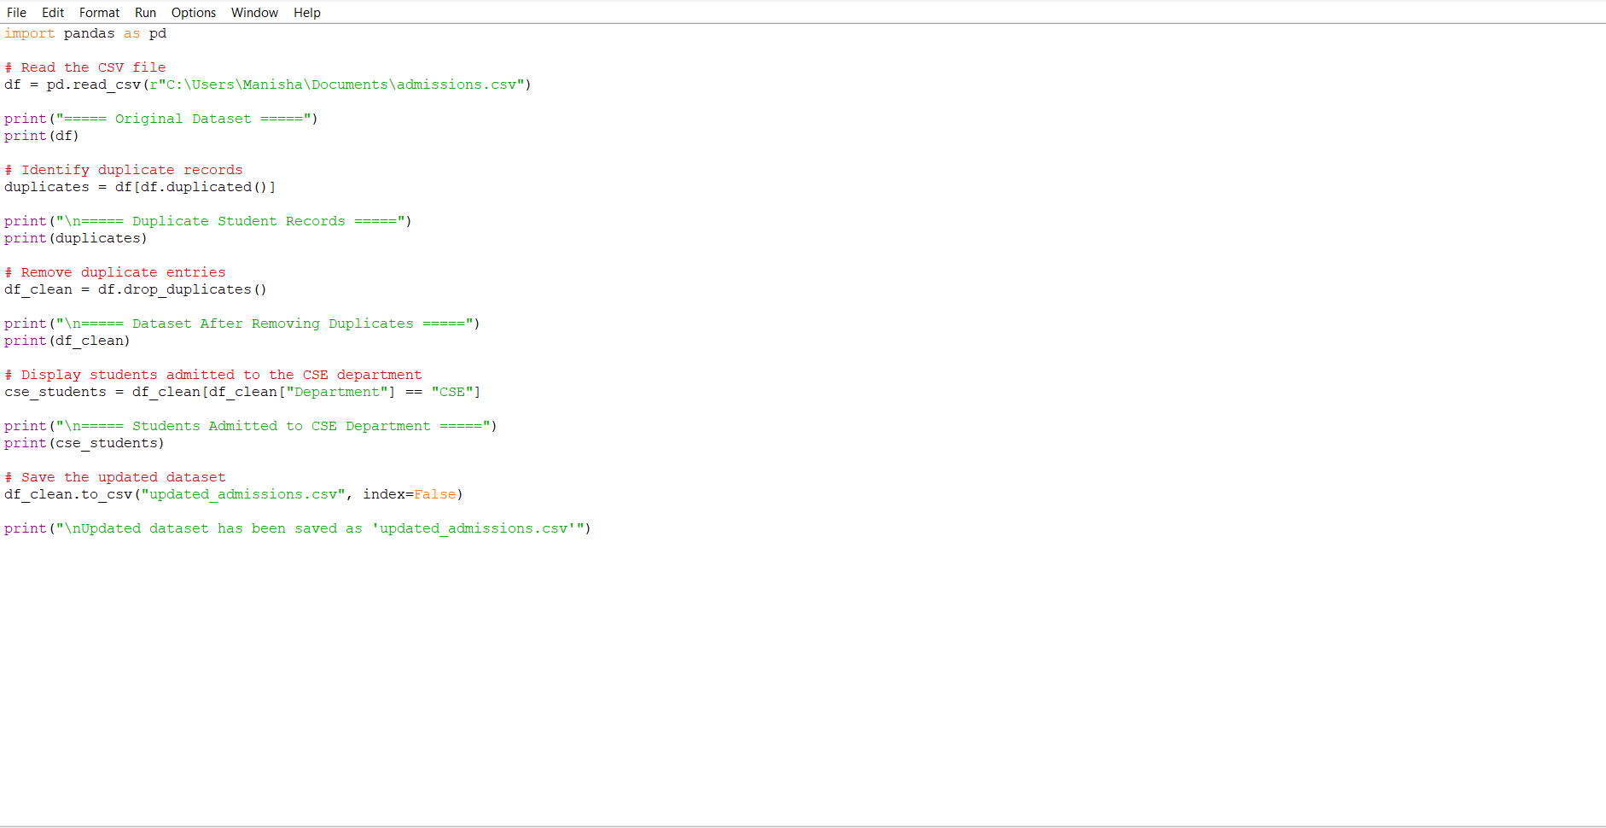

OUTPUT:
